Waverly Park School
3800 Park Ave
Brandon MB
R7A 3X2
(204) 729-3251
(204) 729-3252 (fax)
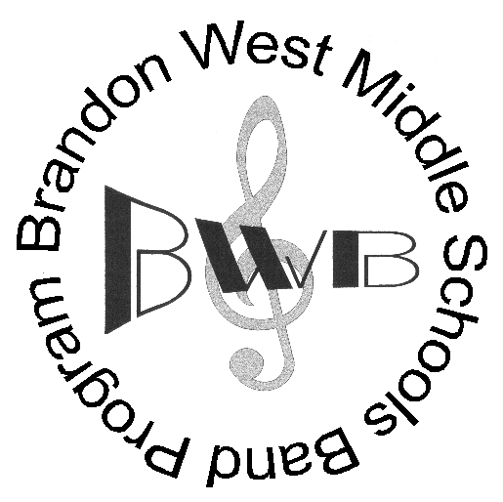
Brandon West Middle Schools Bands
September 6, 2022

Dear parents/guardians and students,

If we have not yet had the opportunity to meet you, welcome to the Brandon West Middle Schools Band program. As directors of the BWMSB band program housed at Waverly Park school we are so excited for the upcoming band year as we eagerly look forward to creating a unique, meaningful, and valuable music education experience for all our students.

- IMPORTANT: All parents need to email cramer.graydon@bsd.ca ASAP to be put on the band e-mail list and obtain an electronic copy of the BWMSB band handbook for 2022-2023.

Grade 7 students in the BWMSB program go through an instrument trial period in September where they try out all the instruments available to see which one is best suited to them. At the end of the month students will choose which instrument they will play. The process will then conclude with “Kickstart” on Thursday, October 6th where each student will participate in a half day workshop on their instrument with professional clinicians from Winnipeg, Brandon, and Brandon University. The BSIMA instrument usage form and corresponding fees must be returned ASAP, prior to the students acquiring their instruments. Please leave the “instrument” and “serial number” spaces of the form blank as they will be filled in when the students have chosen and are assigned their own instrument.

Grade 8 students should return their BSIMA instrument usage form and corresponding fees ASAP. These must be received and completed prior to the students acquiring their instruments. Please leave the “instrument” and “serial number” spaces of the form blank for us to fill out.

BSIMA Instrument Usage fee - $125 for the school year (includes instrument and maintenance supplies)
Financial assistance available (ask your band teacher for a form)
Cheques can be made payable to BSIMA and/or an e-transfer sent to adminofficer@bsima.ca

All band parents are strongly encouraged to attend the parent meeting and AGM that will happen on Wednesday, Sept. 21st at 7:00pm at Earl Oxford School (Gym) – 540 18th Street. At the end of this meeting the BWMSB and BSIMA executive council will be elected. Several positions are available for this coming year (mark on volunteer form if you are interested).

If you have concerns about costs or any other matter, please feel free to contact us at 729-3251 or by e-mail at cramer.graydon@bsd.ca or friesen.brooklyn@bsd.ca .

Sincerely,
Graydon Cramer/Brooklyn Friesen
BWMSB

