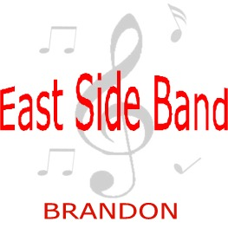
Erin Dodds
Earl Oxford School
540-18th Street
Brandon, MB
R7A 5B2
(204) 729-3277
dodds.erin@bsd.ca

Brandon East Side Band

Dear East Side Band Parents/Guardians,

We have a special event planned the evening of September 28th for all band students. The Dirty Catfish Brass Band (www.dirtycatfishbrassband.com) will be playing a concert at the Westman Centennial Auditorium at 7:30pm. This event is free for all students as it is being sponsored by BSIMA, BWMSB, and East Side Bands. Public tickets are also available for $20 and can be purchased through Mr. Cramer (cramer.graydon@bsd.ca) by cash, cheque (“BWMSB”), or e-transfer (bwmsbtreasurer@gmail.com).

Please complete the following survey to indicate whether your child will be joining us for this event using either the QR code or URL. https://forms.office.com/r/5szfeczunT

Erin Dodds
Earl Oxford School
540-18th Street
Brandon, MB
R7A 5B2
(204) 729-3277
dodds.erin@bsd.ca

Brandon East Side Band

Dear East Side Band Parents/Guardians,

We have a special event planned the evening of September 28th for all band students. The Dirty Catfish Brass Band (www.dirtycatfishbrassband.com) will be playing a concert at the Westman Centennial Auditorium at 7:30pm. This event is free for all students as it is being sponsored by BSIMA, BWMSB, and East Side Bands. Public tickets are also available for $20 and can be purchased through Mr. Cramer (cramer.graydon@bsd.ca) by cash, cheque (“BWMSB”), or e-transfer (bwmsbtreasurer@gmail.com).

Please complete the following survey to indicate whether your child will be joining us for this event using either the QR code or URL. https://forms.office.com/r/5szfeczunT

